COP 2805 ADV JAVA PROGRAMMING

Prof: Nguyen, Hien

Summer 2013

**Math Game Android Application**

**08/01/13**

**Joseph Casal**

**Jorge Varela**

**Fernando Acosta**

**Project Description**

The project is an android entertainment application where the user can test and improve their speed on their basic math skills. During the game activities, the user solves multiple basic and challenging equations. The application will feature four game modes (easy, medium, hard, and challenge). There is also a practice section where the user can change the options for their practice game and go back to the default options. These options are saved for improved user interaction. There is also a high scores menu that will show the best score for each game mode and allow the user to reset the scores.

Program Flow

* **Start Screen/Menu**
  + PLAY
    - Easy
      * Addition, Subtraction, from 0 to 20 (20 questions)
    - Medium
      * Addition, Subtraction 0 – 30, Multiplication 0 - 12 (20 questions)
    - Hard
      * Addition Subtraction 0 – 50, Multiplication Division 0 – 12 (20 questions)
    - Practice
      * Can edit operators and length of numbers
    - Challenge
      * How far you can get with only 3 strikes (have to solve each question in 5 sec)
  + High Score Board
    - Score for easy medium hard
      * Your score : time you took to solve 20 questions + 5 penalty for wrong answers
      * Show best score for each game mode
    - Score for challenge
      * It will be by how many questions you did
    - User can delete the scores
  + Sound OFF/ON

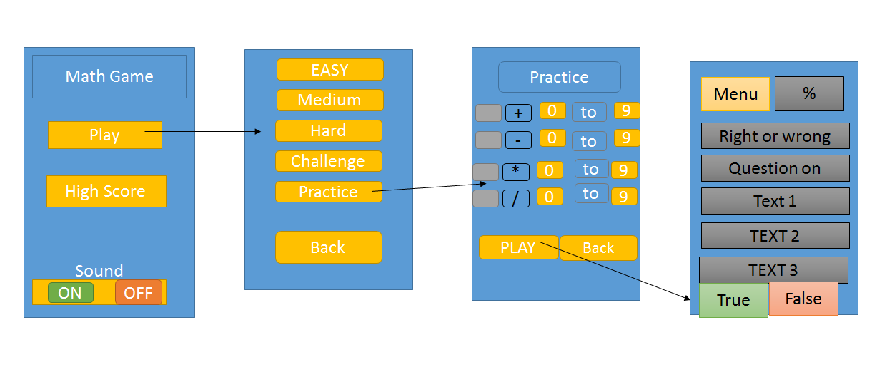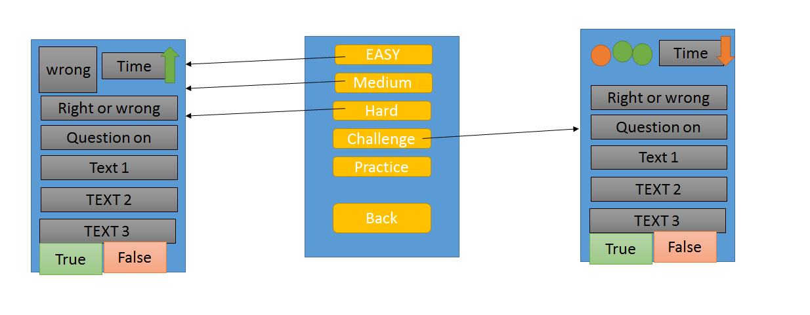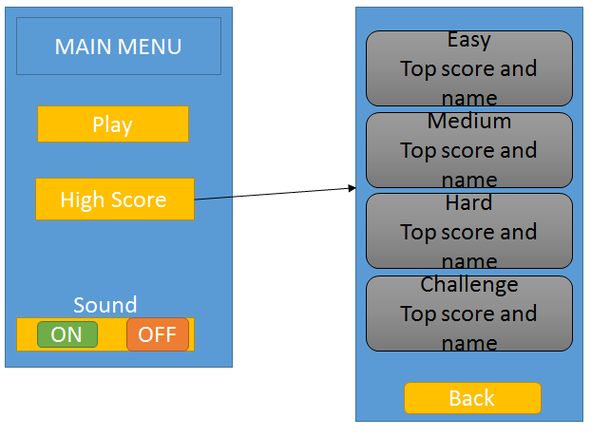

UML Use Case Diagram

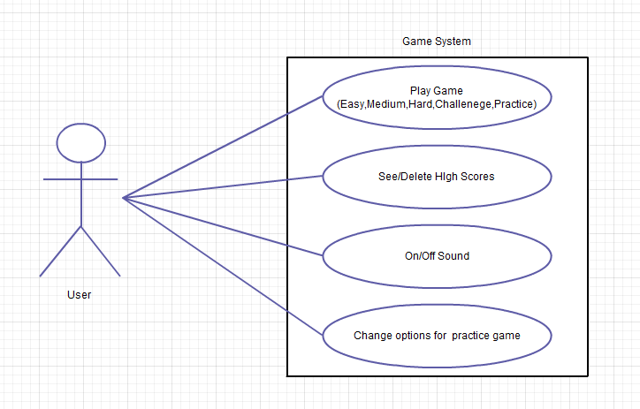

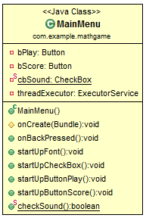

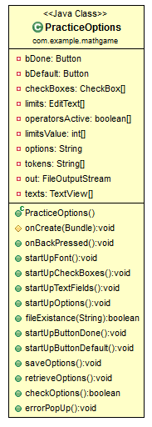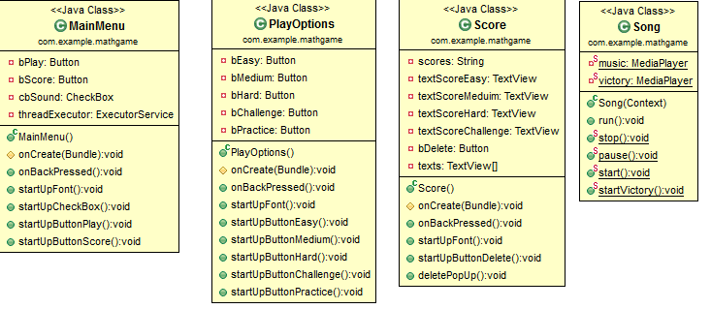

**UML Class Diagrams**

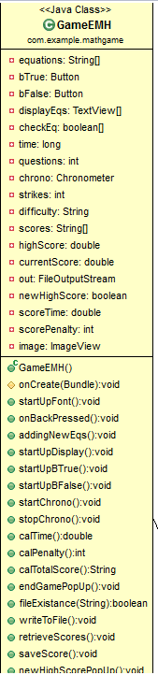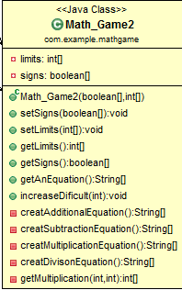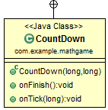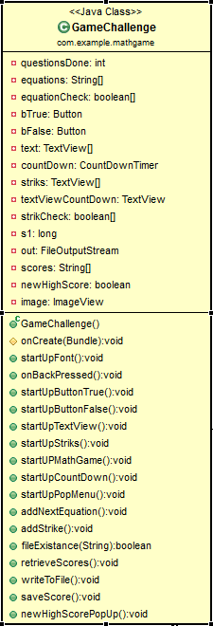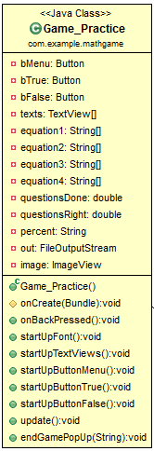

-mathGame

-mathGame

-math

**MainMenu.java**

**package** com.example.mathgame;

**import** java.util.concurrent.ExecutorService;

**import** java.util.concurrent.Executors;

**import** android.app.Activity;

**import** android.content.Intent;

**import** android.graphics.Color;

**import** android.graphics.Typeface;

**import** android.os.Bundle;

**import** android.view.View;

**import** android.widget.Button;

**import** android.widget.CheckBox;

**public** **class** MainMenu **extends** Activity {

**private** Button bPlay,bScore;

**private** CheckBox cbSound;

**private** ExecutorService threadExecutor;

@Override

**protected** **void** onCreate(Bundle savedInstanceState) {

**super**.onCreate(savedInstanceState);

setContentView(R.layout.*activity_main_menu*);

startUpButtonPlay();

startUpButtonScore();

startUpCheckBox();

startUpFont();

threadExecutor = Executors.*newCachedThreadPool*();

threadExecutor.execute(**new** Song(MainMenu.**this**));

threadExecutor.shutdown();

}

@Override

**public** **void** onBackPressed() {

**super**.onBackPressed();

Song.*pause*();

}

// adds a new font from the assets folder/ font

**public** **void** startUpFont(){

Typeface crayon_crumble = Typeface.*createFromAsset*(getAssets(), "fonts/dk_crayon_crumble.ttf");

bPlay.setTypeface(crayon_crumble); // set the font for all the buttons to crayon_crumble

bScore.setTypeface(crayon_crumble);

}

**public** **void** startUpCheckBox(){

cbSound = (CheckBox) findViewById(R.id.*checkBoxSound*);

cbSound.setButtonDrawable(getResources().getDrawable(R.drawable.*sound_on*));

cbSound.setOnClickListener(**new** View.OnClickListener(){

@Override

**public** **void** onClick(View v) {

**if**(cbSound.isChecked()){

cbSound.setButtonDrawable(getResources().getDrawable(R.drawable.*sound_off*));

Song.*pause*();

}

**else**{

cbSound.setButtonDrawable(getResources().getDrawable(R.drawable.*sound_on*));

Song.*start*();

}

}

});

}

**public** **void** startUpButtonPlay(){

bPlay = (Button) findViewById(R.id.*buttonPlay*);

bPlay.setOnClickListener(**new** View.OnClickListener() {

@Override

**public** **void** onClick(View v) {

Intent startPlayOptions = **new** Intent("com.example.mathgame.PLAYOPTIONS");

startActivity(startPlayOptions);

}

});

bPlay.setTextColor(Color.*WHITE*);

}

**public** **void** startUpButtonScore(){

bScore = (Button) findViewById(R.id.*buttonScore*);

bScore.setOnClickListener(**new** View.OnClickListener() {

@Override

**public** **void** onClick(View v) {

Intent startScore = **new** Intent("android.intent.action.SCORE");

startActivity(startScore);

}

});

bScore.setTextColor(Color.*WHITE*);

}

**public** **static** **boolean** checkSound(){

**if**(*cbSound*.isChecked())

**return** **true**;

**else**

**return** **false**;

}

}

**PlayOptions.java**

**package** com.example.mathgame;

**import** android.app.Activity;

**import** android.content.Intent;

**import** android.graphics.Color;

**import** android.graphics.Typeface;

**import** android.os.Bundle;

**import** android.view.View;

**import** android.widget.Button;

**public** **class** PlayOptions **extends** Activity {

**private** Button bEasy, bMedium, bHard, bChallenge, bPractice;

@Override

**protected** **void** onCreate(Bundle playOptionsMenu) {

**super**.onCreate(playOptionsMenu);

setContentView(R.layout.*play_options*);

startUpButtonEasy();

startUpButtonMedium();

startUpButtonHard();

startUpButtonChallenge();

startUpButtonPractice();

startUpFont();

}

@Override

**public** **void** onBackPressed() {

**super**.onBackPressed();

finish();

}

**public** **void** startUpFont(){

Typeface crayon_crumble = Typeface.*createFromAsset*(getAssets(), "fonts/dk_crayon_crumble.ttf");

bEasy.setTypeface(crayon_crumble);

bMedium.setTypeface(crayon_crumble);

bHard.setTypeface(crayon_crumble);

bChallenge.setTypeface(crayon_crumble);

bPractice.setTypeface(crayon_crumble);

}

// methods StartUps

**public** **void** startUpButtonEasy() {

bEasy = (Button) findViewById(R.id.*buttonEasy*);

bEasy.setOnClickListener(**new** View.OnClickListener() {

@Override

**public** **void** onClick(View v) {

Intent openGameE = **new** Intent("com.example.mathgame.GAMEEMH");

**boolean** [] check = {**true**,**true**,**false**,**false**};// addition and subtraction only

**int** [] limits = { 0, 20, 0, 20, 0, 0, 0, 0 };// from 0 to 20

String difficulty = "easy";

openGameE.putExtra("check", check);

openGameE.putExtra("limits", limits);

openGameE.putExtra("difficulty", difficulty);

startActivity(openGameE);

finish();

}

});// end of click listener method

bEasy.setTextColor(Color.*WHITE*);

}// end start up method for easy button

**public** **void** startUpButtonMedium() {

bMedium = (Button) findViewById(R.id.*buttonMedium*);

bMedium.setOnClickListener(**new** View.OnClickListener() {

@Override

**public** **void** onClick(View v) {

Intent openGameE = **new** Intent("com.example.mathgame.GAMEEMH");

**boolean** [] check = {**true**,**true**,**true**,**false**};// addition, subtraction and multiplication

**int** [] limits = { 0, 30, 0, 30, 0, 12, 0, 0 };// add and sub from 0 to 30, mul from 0 to 12

String difficulty = "meduim";

openGameE.putExtra("check", check);

openGameE.putExtra("limits", limits);

openGameE.putExtra("difficulty", difficulty);

startActivity(openGameE);

finish();

}

});// end of click listener method

bMedium.setTextColor(Color.*WHITE*);

}// end start up method for Medium button

**public** **void** startUpButtonHard() {

bHard = (Button) findViewById(R.id.*buttonHard*);

bHard.setOnClickListener(**new** View.OnClickListener() {

@Override

**public** **void** onClick(View v) {

Intent openGameE = **new** Intent("com.example.mathgame.GAMEEMH");

**boolean** [] check = {**true**,**true**,**true**,**true**};

**int** [] limits = { 0, 50, 0, 50, 0, 12, 0, 12};

String difficulty = "hard";

openGameE.putExtra("check", check);

openGameE.putExtra("limits", limits);

openGameE.putExtra("difficulty", difficulty);

startActivity(openGameE);

finish();

}

});// end of click listener method

bHard.setTextColor(Color.*WHITE*);

}// end start up method for Hard button

**public** **void** startUpButtonChallenge() {

bChallenge = (Button) findViewById(R.id.*buttonChallenge*);

bChallenge.setOnClickListener(**new** View.OnClickListener() {

@Override

**public** **void** onClick(View v) {

Intent startGameChallenge = **new** Intent("android.intent.action.GAMECHALLENGE");

startActivity(startGameChallenge);

finish();

}

});// end of click listener method

bChallenge.setTextColor(Color.*WHITE*);

}// end start up method for Challenge button

**public** **void** startUpButtonPractice() {

bPractice = (Button) findViewById(R.id.*buttonPractice*);

bPractice.setOnClickListener(**new** View.OnClickListener() {

@Override

**public** **void** onClick(View v) {

Intent startPracticeOptions = **new** Intent("android.intent.action.PRACTICEOPTIONS");

startActivity(startPracticeOptions);

finish();

}

});// end of click listener method

bPractice.setTextColor(Color.*WHITE*);

}// end start up method for Practice button

}

**GameEMH.java**

**package** com.example.mathgame;

**import** java.io.BufferedReader;

**import** java.io.File;

**import** java.io.FileInputStream;

**import** java.io.FileOutputStream;

**import** java.io.InputStreamReader;

**import** java.text.NumberFormat;

**import** android.app.Activity;

**import** android.app.AlertDialog;

**import** android.app.AlertDialog.Builder;

**import** android.content.Context;

**import** android.content.DialogInterface;

**import** android.content.Intent;

**import** android.graphics.Color;

**import** android.graphics.Typeface;

**import** android.os.Bundle;

**import** android.os.SystemClock;

**import** android.view.View;

**import** android.widget.Button;

**import** android.widget.Chronometer;

**import** android.widget.ImageView;

**import** android.widget.TextView;

**public** **class** GameEMH **extends** Activity {

**private** Math_Game2 mathGame;

**private** String[] equations;

**private** Button bTrue, bFalse;

**private** TextView[] displayEqs;

**private** **boolean**[] checkEq;

**private** **long** time = 0;

**private** **int** questions = 0;

**private** Chronometer chrono;

**private** **int** strikes;

**private** String difficulty;

**private** String[] scores;

**private** **double** highScore;

**private** **double** currentScore;

**private** FileOutputStream out;

**private** **boolean** newHighScore;

**private** **double** scoreTime;

**private** **int** scorePenalty;

**private** ImageView image;

@Override

**protected** **void** onCreate(Bundle savedInstanceState) {

**super**.onCreate(savedInstanceState);

setContentView(R.layout.*game*);

Bundle extras = getIntent().getExtras();

mathGame = **new** Math_Game2(extras.getBooleanArray("check"),extras.getIntArray("limits"));

difficulty = extras.getString("difficulty");

newHighScore = **false**;

startUpDisplay();

startUpBTrue();

startUpBFalse();

startChrono();

startUpFont();

}

**public** **void** startUpFont(){

Typeface crayon_crumble = Typeface.*createFromAsset*(getAssets(), "fonts/dk_crayon_crumble.ttf");

**for** (**int** i = 0; i < displayEqs.length; i++) {

displayEqs[i].setTypeface(crayon_crumble);

displayEqs[i].setTextColor(Color.*WHITE*);

}

bFalse.setTypeface(crayon_crumble);

bFalse.setTextColor(Color.*WHITE*);

bTrue.setTypeface(crayon_crumble);

bTrue.setTextColor(Color.*WHITE*);

chrono.setTypeface(crayon_crumble);

chrono.setTextColor(Color.*WHITE*);

}

//when the back button is pressed on the phone

@Override

**public** **void** onBackPressed() {

stopChrono();

displayEqs[1].setText("");

displayEqs[2].setText("");

displayEqs[3].setText("");

displayEqs[4].setText("");

Builder box = **new** AlertDialog.Builder(**this**);

box.setMessage("Are you sure you want to exit?");

box.setCancelable(**false**);

box.setPositiveButton("Yes", **new** DialogInterface.OnClickListener() {

**public** **void** onClick(DialogInterface dialog, **int** id) {

Intent startPlayOptions = **new** Intent("com.example.mathgame.PLAYOPTIONS");

startActivity(startPlayOptions);

finish();

}

});

box.setNegativeButton("No", **new** DialogInterface.OnClickListener() {

**public** **void** onClick(DialogInterface dialog, **int** id) {

startChrono();

dialog.cancel();

displayEqs[1].setText(equations[0]);

displayEqs[2].setText(equations[1]);

displayEqs[3].setText(equations[2]);

displayEqs[4].setText(equations[3]);

}

});

box.show();

}

**public** **void** addingNewEqs() {

String[] n = mathGame.getAnEquation();

questions++;

displayEqs[0].setText(equations[0]);

**for** (**int** i = 0; i < equations.length - 1; i++) {

equations[i] = equations[i + 1];

checkEq[i] = checkEq[i + 1];

displayEqs[i + 1].setText(equations[i]);

}// end for loop

equations[equations.length - 1] = n[0];

checkEq[checkEq.length - 1] = ((n[1].trim().equals("0"))? **false** : **true**);

displayEqs[displayEqs.length - 1].setText(n[0]);

}// end addingNewEqs method

**public** **void** startUpDisplay() {

**int** size = 4;

displayEqs = **new** TextView[size + 1];

displayEqs[0] = (TextView) findViewById(R.id.*viewLastEquation_EMH*);

displayEqs[1] = (TextView) findViewById(R.id.*viewEquation1_EMH*);

displayEqs[2] = (TextView) findViewById(R.id.*viewEquation2_EMH*);

displayEqs[3] = (TextView) findViewById(R.id.*viewEquation3_EMH*);

displayEqs[4] = (TextView) findViewById(R.id.*viewEquation4_EMH*);

image = (ImageView) findViewById(R.id.*imageView_EMH*);

equations = **new** String[size];

checkEq = **new** **boolean**[size];

**for** (**int** i = 0; i < size; i++) {

String[] n = mathGame.getAnEquation();

equations[i] = n[0];

checkEq[i] = ((n[1].trim().equals("0")) ? **false** : **true**);

displayEqs[i + 1].setText(n[0]);

}// end for loop

}// end startUpDisplay method

**public** **void** startUpBTrue() { // setting button true

bTrue = (Button) findViewById(R.id.*buttonTrue_EMH*);

bTrue.setOnClickListener(**new** View.OnClickListener() {

**public** **void** onClick(View v) {

**if** (!checkEq[0]) {

strikes++;

image.setBackgroundDrawable(getResources().getDrawable(R.drawable.*wrong*));

} **else** {

image.setBackgroundDrawable(getResources().getDrawable(R.drawable.*right*));

}

addingNewEqs();

**if**(questions == 20){

stopChrono();

scoreTime = calTime();

scorePenalty = calPenalty();

calTotalScore();

saveScore();

**if**(newHighScore)

newHighScorePopUp();

**else**

endGamePopUp();

}

**if**(questions == 17){

displayEqs[4].setText("");

}

**if**(questions == 18){

displayEqs[3].setText("");

displayEqs[4].setText("");

}

**if**(questions == 19){

displayEqs[2].setText("");

displayEqs[3].setText("");

displayEqs[4].setText("");

}

**if**(questions == 20){

displayEqs[1].setText("");

displayEqs[2].setText("");

displayEqs[3].setText("");

displayEqs[4].setText("");

}

}// end method onCLick

});// end of method setOnClickListner from class Button

} // end of public method set up true button

**public** **void** startUpBFalse() {// setting button false

bFalse = (Button) findViewById(R.id.*buttonFalse_EMH*);

bFalse.setOnClickListener(**new** View.OnClickListener() {

**public** **void** onClick(View v) {

**if** (checkEq[0]) {

strikes++;

image.setBackgroundDrawable(getResources().getDrawable(R.drawable.*wrong*));

} **else** {

image.setBackgroundDrawable(getResources().getDrawable(R.drawable.*right*));

}

addingNewEqs();

**if**(questions == 20){

stopChrono();

scoreTime = calTime();

scorePenalty = calPenalty();

calTotalScore();

saveScore();

**if**(newHighScore)

newHighScorePopUp();

**else**

endGamePopUp();

}

**if**(questions == 17){

displayEqs[4].setText("");

}

**if**(questions == 18){

displayEqs[3].setText("");

displayEqs[4].setText("");

}

**if**(questions == 19){

displayEqs[2].setText("");

displayEqs[3].setText("");

displayEqs[4].setText("");

}

**if**(questions == 20){

displayEqs[1].setText("");

displayEqs[2].setText("");

displayEqs[3].setText("");

displayEqs[4].setText("");

}

}// end method onCLick

});// end of method setOnClickListner from class Button

} // end of public method set up true button

**public** **void** startChrono(){

chrono = (Chronometer)findViewById(R.id.*timerEMH*);

chrono.setBase(SystemClock.*elapsedRealtime*()+time);

chrono.start();

}

**public** **void** stopChrono(){

time = chrono.getBase() - SystemClock.*elapsedRealtime*();

chrono.stop();

}

//calculates the time

**public** **double** calTime(){

**double** result;

result= (SystemClock.*elapsedRealtime*() - chrono.getBase());

**double** endResult = (**double**)result/1000;

**return** endResult;

}

//calculates the penalty according to the strikes

**public** **int** calPenalty(){

**int** penalty = (strikes * 5);

**return** penalty;

}

//calcs the total score

**public** String calTotalScore(){

**double** totalScore = scoreTime + scorePenalty;

//formats the total score 3 numbers after the dot

NumberFormat nf = NumberFormat.*getInstance*();

nf.setMaximumFractionDigits(3);

nf.setMaximumFractionDigits(3);

String output = nf.format(totalScore);

currentScore = Double.*parseDouble*(output);

**return** output;

}//end calTotalScore

**public** **void** endGamePopUp(){

Builder dialogbox = **new** AlertDialog.Builder(**this**);

dialogbox.setCancelable(**false**);

dialogbox.setMessage((20 - strikes) + " right out of 20, " + strikes + " wrong, in " + scoreTime +

" seconds + " + scorePenalty + " penalty = " + calTotalScore() + " seconds." +

"\n Do you want to continue playing?");

dialogbox.setNegativeButton("no", **new** DialogInterface.OnClickListener() {

@Override

**public** **void** onClick(DialogInterface dialog, **int** which) {

Intent startPlayOptions = **new** Intent("com.example.mathgame.PLAYOPTIONS");

startActivity(startPlayOptions);

finish();

}

});

dialogbox.setPositiveButton("yes", **new** DialogInterface.OnClickListener() {

@Override

**public** **void** onClick(DialogInterface dialog, **int** which) {

Intent startGameEMH = getIntent();

startActivity(startGameEMH);

finish();

}

});

dialogbox.show();

}//end endGamePopUp method

**public** **boolean** fileExistance(String fname){

File file = getBaseContext().getFileStreamPath(fname);

**if**(file.exists()){

**return** **true**;

}

**else**{

**return** **false**;

}

}

**public** **void** writeToFile(){

**try**{

String output = scores[0] + " " + scores[1] + " " + scores[2]

+ " " + scores[3];

out = openFileOutput("scores", Context.*MODE_PRIVATE*);

out.write(output.getBytes());

out.close();

}**catch**(Exception e){

}

}

**public** **void** retrieveScores() **throws** Exception{

FileInputStream in = openFileInput("scores");

InputStreamReader isr = **new** InputStreamReader(in);

BufferedReader bufferedReader = **new** BufferedReader(isr);

String receiveString = "";

StringBuilder stringBuilder = **new** StringBuilder();

**while** ( (receiveString = bufferedReader.readLine()) != **null** ) {

stringBuilder.append(receiveString);

}

in.close();

scores = stringBuilder.toString().split(" ");

}

**public** **void** saveScore(){

**try** {

**if**(fileExistance("scores")){

retrieveScores();

**if**(difficulty.equals("easy")){

**if**(scores[0].equals("#")){

scores[0] = currentScore + "";

writeToFile();

}

**else**{

highScore = Double.*parseDouble*(scores[0]);

**if**(currentScore < highScore){

scores[0] = currentScore + "";

newHighScore = **true**;

writeToFile();

}

}

}

**else** **if**(difficulty.equals("meduim")){

**if**(scores[1].equals("#")){

scores[1] = currentScore + "";

writeToFile();

}

**else**{

highScore = Double.*parseDouble*(scores[1]);

**if**(currentScore < highScore){

scores[1] = currentScore + "";

newHighScore = **true**;

writeToFile();

}

}

}

**else**{

**if**(scores[2].equals("#")){

scores[2] = currentScore + "";

writeToFile();

}

**else**{

highScore = Double.*parseDouble*(scores[2]);

**if**(currentScore < highScore){

scores[2] = currentScore + "";

newHighScore = **true**;

writeToFile();

}

}

}

}

**else**{

**if**(difficulty.equals("easy")){

scores = **new** String[4];

scores[0] = currentScore + "";

scores[1] = "#";

scores[2] = "#";

scores[3] = "#";

writeToFile();

}

**else** **if**(difficulty.equals("meduim")){

scores = **new** String[4];

scores[0] = "#";

scores[1] = currentScore + "";

scores[2] = "#";

scores[3] = "#";

writeToFile();

}

**else**{

scores = **new** String[4];

scores[0] = "#";

scores[1] = "#";

scores[2] = currentScore + "";

scores[3] = "#";

writeToFile();

}

}

} **catch** (Exception e) {

e.printStackTrace();

}

}

**public** **void** newHighScorePopUp(){

Builder dialogbox = **new** AlertDialog.Builder(**this**);

dialogbox.setCancelable(**false**);

dialogbox.setMessage("Congratulations, you just got a new high score!!!!\n" + (20 - strikes) +

" right, " + strikes + " wrong, in " + scoreTime + " seconds + " + scorePenalty +

" penalty = " + calTotalScore()+ " seconds."+ "\n Do you want to continue playing?");

dialogbox.setNegativeButton("no", **new** DialogInterface.OnClickListener() {

@Override

**public** **void** onClick(DialogInterface dialog, **int** which) {

finish();

}

});

dialogbox.setPositiveButton("yes", **new** DialogInterface.OnClickListener() {

@Override

**public** **void** onClick(DialogInterface dialog, **int** which) {

Intent startGameEMH = getIntent();

startActivity(startGameEMH);

finish();

}

});

dialogbox.show();

**if**(!MainMenu.*checkSound*()){

Song.*startVictory*();

}

}

}

**GameChallenge.java**

**package** com.example.mathgame;

**import** java.io.BufferedReader;

**import** java.io.File;

**import** java.io.FileInputStream;

**import** java.io.FileOutputStream;

**import** java.io.InputStreamReader;

**import** android.app.Activity;

**import** android.app.AlertDialog;

**import** android.app.AlertDialog.Builder;

**import** android.content.Context;

**import** android.content.DialogInterface;

**import** android.content.Intent;

**import** android.graphics.Color;

**import** android.graphics.Typeface;

**import** android.os.Bundle;

**import** android.os.CountDownTimer;

**import** android.view.View;

**import** android.widget.Button;

**import** android.widget.ImageView;

**import** android.widget.TextView;

**public** **class** GameChallenge **extends** Activity{

**private** **int** questionsDone;

**private** String[] equations;

**private** **boolean**[] equationCheck;

**private** Button bTrue, bFalse;

**private** TextView[] text;

**private** CountDownTimer countDown;

**private** TextView[] striks;

**private** TextView textViewCountDown;

**private** **boolean**[] strikCheck;

**private** Math_Game2 mathGame;

**private** **long** s1;

**private** FileOutputStream out;

**private** String[] scores;

**private** **boolean** newHighScore;

**private** ImageView image;

@Override

**protected** **void** onCreate(Bundle gameChallengeBundle) {

**super**.onCreate(gameChallengeBundle);

**this**.setContentView(R.layout.*game_challenge*);

questionsDone = 0;

newHighScore = **false**;

startUPMathGame();

startUpTextView();

startUpButtonFalse();

startUpButtonTrue();

startUpStriks();

startUpFont();

}

**public** **void** startUpFont(){

Typeface crayon_crumble = Typeface.*createFromAsset*(getAssets(), "fonts/dk_crayon_crumble.ttf");

bTrue.setTypeface(crayon_crumble); // set the font for all the buttons to crayon_crumble

bTrue.setTextColor(Color.*WHITE*);

bFalse.setTypeface(crayon_crumble);

bFalse.setTextColor(Color.*WHITE*);

textViewCountDown.setTypeface(crayon_crumble);

textViewCountDown.setTextColor(Color.*WHITE*);

**for** (**int** i = 0; i < text.length; i++) {

text[i].setTypeface(crayon_crumble);

text[i].setTextColor(Color.*WHITE*);

}

}

//when the back button is pressed on the phone

@Override

**public** **void** onBackPressed() {

**if**(countDown != **null**)

countDown.cancel();

text[1].setText("");

text[2].setText("");

text[3].setText("");

text[4].setText("");

Builder box = **new** AlertDialog.Builder(**this**);

box.setMessage("Are you sure you want to exit?");

box.setCancelable(**false**);

box.setPositiveButton("Yes", **new** DialogInterface.OnClickListener() {

**public** **void** onClick(DialogInterface dialog, **int** id) {

Intent startPlayOptions = **new** Intent("com.example.mathgame.PLAYOPTIONS");

startActivity(startPlayOptions);

finish();

}

});

box.setNegativeButton("No", **new** DialogInterface.OnClickListener() {

**public** **void** onClick(DialogInterface dialog, **int** id) {

**if**(countDown != **null**){

countDown = **new** CountDown(s1,100);

countDown.start();

dialog.cancel();

text[1].setText(equations[0]);

text[2].setText(equations[1]);

text[3].setText(equations[2]);

text[4].setText(equations[3]);

}

**else**{

text[1].setText(equations[0]);

text[2].setText(equations[1]);

text[3].setText(equations[2]);

text[4].setText(equations[3]);

}

}

});

box.show();

}

//start up method

**public** **void** startUpButtonTrue(){

bTrue = (Button) findViewById(R.id.*buttonTrue_Challenge*);

bTrue.setOnClickListener(**new** View.OnClickListener() {

@Override

**public** **void** onClick(View v) {

**if**(!equationCheck[0]){

**try** {

addStrike();

} **catch** (Exception e) {

e.printStackTrace();

}

image.setBackgroundDrawable(getResources().getDrawable(R.drawable.*wrong*));

} **else** {

image.setBackgroundDrawable(getResources().getDrawable(R.drawable.*right*));

}

addNextEquation();

}

});//end of method clickListener

}//end of method StartUpButtonTrue

**public** **void** startUpButtonFalse(){

bFalse = (Button) findViewById(R.id.*buttonFalse_Challenge*);

bFalse.setOnClickListener(**new** View.OnClickListener() {

@Override

**public** **void** onClick(View v) {

**if**(equationCheck[0]){

**try** {

addStrike();

} **catch** (Exception e) {

e.printStackTrace();

}

image.setBackgroundDrawable(getResources().getDrawable(R.drawable.*wrong*));

} **else** {

image.setBackgroundDrawable(getResources().getDrawable(R.drawable.*right*));

}

addNextEquation();

}

});//end of method clickListener

}//end of method StartUpButtonFalse

**public** **void** startUpTextView(){

**int** size = 4;

text = **new** TextView[size + 1];

text[0] = (TextView) findViewById(R.id.*viewLastEquation_Challenge*);

text[1] = (TextView) findViewById(R.id.*viewEquation1_Challenge*);

text[2] = (TextView) findViewById(R.id.*viewEquation2_Challenge*);

text[3] = (TextView) findViewById(R.id.*viewEquation3_Challenge*);

text[4] = (TextView) findViewById(R.id.*viewEquation4_Challenge*);

image = (ImageView) findViewById(R.id.*imageView_Challenge*);

equations = **new** String[size];

equationCheck = **new** **boolean**[size];

**for** (**int** i = 0; i < size; i++) {

String[] n = mathGame.getAnEquation();

equations[i] = n[0];

equationCheck[i] = ((n[1].trim().equals("0"))? **false** : **true**);

text[i + 1].setText(n[0]);

}//end for loop

textViewCountDown = (TextView) findViewById(R.id.*countDownChallenge*);

textViewCountDown.setText("5.00");

}//end method StartUpTextView

**public** **void** startUpStriks(){

striks = **new** TextView[3];

strikCheck = **new** **boolean**[3];

striks[0] = (TextView) findViewById(R.id.*textViewStrick1*);

striks[1] = (TextView) findViewById(R.id.*textViewStrick2*);

striks[2] = (TextView) findViewById(R.id.*textViewStrick3*);

**for** (**int** i = 0; i < striks.length; i++) {

strikCheck[i] = **true**;

}//end for loop

}//end method startUpStriks

**public** **void** startUPMathGame(){

**boolean**[] check = {**true**,**true**,**true**,**true**};

**int**[] num = {0,10,0,10,0,10,0,10};

mathGame = **new** Math_Game2(check,num);

}//end method startUpMathGame

**public** **void** startUpCountDown(){

**if**(strikCheck[2]){

countDown = **new** CountDown(5000,50);

countDown.start();

}

}

**public** **void** startUpPopMenu(){

textViewCountDown.setText("0.00");

Builder dialogBox = **new** AlertDialog.Builder(**this**);

dialogBox.setTitle("Game Over");

dialogBox.setMessage("You solved " + (questionsDone - 3)

+ " questions\n Do you want to continue? ");

dialogBox.setCancelable(**false**);

dialogBox.setNegativeButton("No",

**new** DialogInterface.OnClickListener() {

@Override

**public** **void** onClick(DialogInterface dialog, **int** which) {

**try** {

writeToFile();

} **catch** (Exception e) {

e.printStackTrace();

}

Intent startPlayOptions = **new** Intent("com.example.mathgame.PLAYOPTIONS");

startActivity(startPlayOptions);

finish();

}

});

dialogBox.setPositiveButton("Yes", **new** DialogInterface.OnClickListener() {

//restarts game challenge when user want to continue

@Override

**public** **void** onClick(DialogInterface dialog, **int** which) {

**try** {

writeToFile();

} **catch** (Exception e) {

e.printStackTrace();

}

Intent startGameChallenge = getIntent();

startActivity(startGameChallenge);

finish();

}

});

dialogBox.show();

}

//making dialog box

//other public methods

**public** **void** addNextEquation(){

String[] n = mathGame.getAnEquation();

mathGame.increaseDificult(questionsDone++);

text[0].setText(equations[0]);

**for** (**int** i = 0; i < equations.length - 1; i++) {// move all the equation by 1 up

equations[i] = equations[i + 1];

equationCheck[i] = equationCheck[i + 1];

text[i + 1].setText(equations[i]);

}// end for loop

equations[equations.length - 1] = n[0];

equationCheck[equationCheck.length - 1] = ((n[1].trim().equals("0"))? **false** : **true**);

text[text.length - 1].setText(n[0]);

**if**(countDown != **null**)

countDown.cancel();

startUpCountDown();

}

**public** **void** addStrike() **throws** Exception{

**for** (**int** i = 0; i < strikCheck.length; i++) {

**if**(strikCheck[i]){

strikCheck[i] = **false**;

striks[i].setBackgroundDrawable(getResources().getDrawable(R.drawable.*red_apple*));

**if**(i == 2){

saveScore();

**if**(newHighScore)

newHighScorePopUp();

**else**

startUpPopMenu();

}

**break**;

}// end if

}//end for loop

}//end method strike

//inner class

**public** **class** CountDown **extends** CountDownTimer{

**public** CountDown(**long** millisInFuture, **long** countDownInterval) {

**super**(millisInFuture, countDownInterval);

}

@Override

**public** **void** onFinish() {

**try** {

addStrike();

} **catch** (Exception e) {

e.printStackTrace();

}

addNextEquation();

image.setBackgroundDrawable(getResources().getDrawable(R.drawable.*wrong*));

}

@Override

**public** **void** onTick(**long** millisUntilFinished) {

s1=millisUntilFinished;

textViewCountDown.setText("" + String.*format*("%.2f", millisUntilFinished/1000.0 ));

}

}

**public** **boolean** fileExistance(String fname){

File file = getBaseContext().getFileStreamPath(fname);

**if**(file.exists()){

**return** **true**;

}

**else**{

**return** **false**;

}

}

**public** **void** retrieveScores() **throws** Exception{

FileInputStream in = openFileInput("scores");

InputStreamReader isr = **new** InputStreamReader(in);

BufferedReader bufferedReader = **new** BufferedReader(isr);

String receiveString = "";

StringBuilder stringBuilder = **new** StringBuilder();

**while** ( (receiveString = bufferedReader.readLine()) != **null** ) {

stringBuilder.append(receiveString);

}

in.close();

scores = stringBuilder.toString().split(" ");

}

**public** **void** writeToFile(){

**try**{

String output = scores[0] + " " + scores[1] + " " + scores[2]

+ " " + scores[3];

out = openFileOutput("scores", Context.*MODE_PRIVATE*);

out.write(output.getBytes());

out.close();

}**catch**(Exception e){

}

}

**public** **void** saveScore() **throws** Exception{

**if**(fileExistance("scores")){

retrieveScores();

**if**(scores[3].equals("#")){

scores[3] = (questionsDone - 2) + "";

}**else**{

**int** highScore = Integer.*parseInt*(scores[3]);

**if**((questionsDone - 2) > highScore){

scores[3] = (questionsDone - 2) + "";

newHighScore = **true**;

}

}

}**else**{

scores = **new** String[4];

scores[0] = "#";

scores[1] = "#";

scores[2] = "#";

scores[3] = (questionsDone - 2) + "";

}

questionsDone++;

}

**public** **void** newHighScorePopUp(){

textViewCountDown.setText("0.00");

Builder dialogBox = **new** AlertDialog.Builder(**this**);

dialogBox.setTitle("Game Over");

dialogBox.setMessage("Congratulations, you just got a new high score in Challenge mode!!!!\n" +

"You solved " + (questionsDone - 3)

+ " questions\n Do you want to continue? ");

dialogBox.setCancelable(**false**);

dialogBox.setNegativeButton("No",

**new** DialogInterface.OnClickListener() {

@Override

**public** **void** onClick(DialogInterface dialog, **int** which) {

**try** {

writeToFile();

} **catch** (Exception e) {

e.printStackTrace();

}

finish();

}

});

dialogBox.setPositiveButton("Yes", **new** DialogInterface.OnClickListener() {

//restarts game challenge when user want to continue

@Override

**public** **void** onClick(DialogInterface dialog, **int** which) {

**try** {

writeToFile();

} **catch** (Exception e) {

e.printStackTrace();

}

Intent startGameChallenge = getIntent();

startActivity(startGameChallenge);

finish();

}

});

dialogBox.show();

**if**(!MainMenu.*checkSound*()){

Song.*startVictory*();

}

}

}

**GamePractice.java**

**package** com.example.mathgame;

**import** android.app.Activity;

**import** android.content.Intent;

**import** android.graphics.Color;

**import** android.graphics.Typeface;

**import** android.os.Bundle;

**import** android.view.View;

**import** android.widget.Button;

**import** android.widget.ImageView;

**import** android.widget.TextView;

**public** **class** Game_Practice **extends** Activity {

**private** Button bMenu, bTrue, bFalse;

**private** TextView[] texts;

//equation1, equation2, equation3, equation4, lastEquation, percentRight

**private** Math_Game2 math;

**private** String[] equation1;

**private** String[] equation2;

**private** String[] equation3;

**private** String[] equation4;

**private** **double** questionsDone;

**private** **double** questionsRight;

**private** String percent;

**private** ImageView image;

@Override

**protected** **void** onCreate(Bundle savedInstanceState) {

**super**.onCreate(savedInstanceState);

setContentView(R.layout.*game_practice*);

Bundle extras = getIntent().getExtras();

math = **new** Math_Game2(extras.getBooleanArray("operatorsActive"), extras.getIntArray("limitsValue"));

questionsDone = 0;

questionsRight = 0;

startUpTextViews();

startUpButtonMenu();

startUpButtonTrue();

startUpButtonFalse();

startUpFont();

}

@Override

**public** **void** onBackPressed() {

**super**.onBackPressed();

Intent startPracticeOptions = **new** Intent("android.intent.action.PRACTICEOPTIONS");

startActivity(startPracticeOptions);

finish();

}

**public** **void** startUpFont(){

Typeface crayon_crumble = Typeface.*createFromAsset*(getAssets(), "fonts/dk_crayon_crumble.ttf");

**for** (**int** i = 0; i < texts.length; i++) {

texts[i].setTypeface(crayon_crumble);

texts[i].setTextColor(Color.*WHITE*);

}

bFalse.setTypeface(crayon_crumble);

bFalse.setTextColor(Color.*WHITE*);

bTrue.setTypeface(crayon_crumble);

bTrue.setTextColor(Color.*WHITE*);

bMenu.setTypeface(crayon_crumble);

bMenu.setTextColor(Color.*WHITE*);

}

**public** **void** startUpTextViews(){

texts = **new** TextView[6];

texts[0] = (TextView) findViewById(R.id.*viewEquation1_Practice*);

texts[1] = (TextView) findViewById(R.id.*viewEquation2_Practice*);

texts[2] = (TextView) findViewById(R.id.*viewEquation3_Practice*);

texts[3] = (TextView) findViewById(R.id.*viewEquation4_Practice*);

texts[4] = (TextView) findViewById(R.id.*viewLastEquation_Practice*);

texts[5] = (TextView) findViewById(R.id.*viewPercentRight_Practice*);

equation1 = math.getAnEquation();

equation2 = math.getAnEquation();

equation3 = math.getAnEquation();

equation4 = math.getAnEquation();

texts[0].setText(equation1[0]);

texts[1].setText(equation2[0]);

texts[2].setText(equation3[0]);

texts[3].setText(equation4[0]);

image = (ImageView) findViewById(R.id.*imageView_Practice*);

}

**public** **void** startUpButtonMenu(){

bMenu = (Button) findViewById(R.id.*buttonMenu_Practice*);

bMenu.setOnClickListener(**new** View.OnClickListener() {

@Override

**public** **void** onClick(View v) {

Intent intent = **new** Intent(getApplicationContext(), MainMenu.**class**);

intent.addFlags(Intent.*FLAG_ACTIVITY_CLEAR_TOP*);

startActivity(intent);

}

});

}

**public** **void** startUpButtonTrue(){

bTrue = (Button) findViewById(R.id.*buttonTrue_Practice*);

bTrue.setOnClickListener(**new** View.OnClickListener() {

@Override

**public** **void** onClick(View v) {

texts[4].setText(equation1[0]);

**if**(equation1[1].equals("1")){

image.setBackgroundDrawable(getResources().getDrawable(R.drawable.*right*));

questionsRight++;

}

**else**

image.setBackgroundDrawable(getResources().getDrawable(R.drawable.*wrong*));

update();

}

});

}

**public** **void** startUpButtonFalse(){

bFalse = (Button) findViewById(R.id.*buttonFalse_Practice*);

bFalse.setOnClickListener(**new** View.OnClickListener() {

@Override

**public** **void** onClick(View v) {

texts[4].setText(equation1[0]);

**if**(equation1[1].equals("0")){

image.setBackgroundDrawable(getResources().getDrawable(R.drawable.*right*));

questionsRight++;

}

**else**

image.setBackgroundDrawable(getResources().getDrawable(R.drawable.*wrong*));

update();

}

});

}

**public** **void** update(){

questionsDone++;

texts[0].setText(equation2[0]);

texts[1].setText(equation3[0]);

texts[2].setText(equation4[0]);

equation1 = equation2;

equation2 = equation3;

equation3 = equation4;

equation4 = math.getAnEquation();

texts[3].setText(equation4[0]);

**double** percentNum = (questionsRight/questionsDone) * 100;

percentNum = (**double**)Math.*round*(percentNum*10)/10;

percent = percentNum + "%";

texts[5].setText(percent);

}

}

**Math_Game2.java**

**package** com.example.mathgame;

**public** **class** Math_Game2 {

**private** **int**[] limits; // pos 0: addMin, pos 1: addMax, pos 2: subMin, pos 3: subMax

// pos 4: mulMin, pos 5: mulMax, pos 6: divMin, pos 7: divMax

**private** **boolean**[] signs; // pos 0 : +, pos 1 : -, pos 2: *, pos 3: /;

// constructors

**public** Math_Game2(**boolean**[] signs, **int**[] limits) {

setSigns(signs);

setLimits(limits);

}

// setters

**public** **void** setSigns(**boolean**[] signs) {

**this**.signs = signs;

}

**public** **void** setLimits(**int**[] limits) {

**this**.limits = limits;

}

// getters

**public** **int**[] getLimits() {

**return** limits;

}

**public** **boolean**[] getSigns() {

**return** signs;

}

// methods

**public** String[] getAnEquation() {

// pos 0: equation , pos 1: 0 is false___ 1 is true

**while** (**true**) {

**switch** ((**int**) (Math.*random*() * (4))) {

**case** 0:

**if** (signs[0])

**return** creatAdditionalEquation();

**else**

**continue**;

**case** 1:

**if** (signs[1])

**return** creatSubtractionEquation();

**else**

**continue**;

**case** 2:

**if** (signs[2])

**return** creatMultiplicationEquation();

**else**

**continue**;

**case** 3:

**if** (signs[3])

**return** creatDivisonEquation();

**else**

**continue**;

}// end of switch

}// end of while loop

}// end of getAnEquation method

**public** **void** increaseDificult(**int** num){

**for** (**int** i = 0; i < limits.length; i++) {

**if**(i < 4 ){

**if**(i%2 == 1) // check if is a max

limits[i]++;

**else** **if**(i%2 == 0 && num%5 == 0 && num != 0) // check if is a min

limits[i]++;

} **else** **if**(i%2 == 1 && num%4 == 0 && num != 0)

limits[i]++;

**else** **if**(i%2 == 0 && num%9 == 0 && num != 0)

limits[i]++;

}

}

// private methods

**private** String[] creatAdditionalEquation() {

**int** num1 = (**int**) (limits[0] + Math.*random*() * (limits[1] + 1 - limits[0])); // make

// Number 1

**int** num2 = (**int**) (limits[0] + Math.*random*() * (limits[1] + 1 - limits[0])); // make

// number 2

**int** equals = num1 + num2; // get the sum

**boolean** check = **true**; // is going to say if the equation is true or false

**if** (Math.*random*() < 0.5) { // is going to set the equation false if the

// number is less than 0.5

check = **false**; // set check to false

**int** equals2 = equals; // we have to change the equal

**while** (equals == equals2) {

**if** (((num1 == 1) || (num2 == 1)) && (Math.*random*() < 0.6)){ // if for getting a false equation when the result is 1

**if** (num1 == 1) {

equals2 = num2;

**continue**;

} **else** **if** (num2 == 1) {

equals2 = num1;

**continue**;

}

}**else** {

**if** (limits[1] - limits[0] > 5) {

**int** change = (**int**)((limits[1] - limits[0]) * 0.2);

**if** ((num1 > change || num2 > change)

&& Math.*random*() < 0.5)

equals2 = num2 + num1 - (**int**)(1 + ( 1 +change)*Math.*random*()); // subtract change

**else**

equals2 = num2 + num1 + (**int**)(1 + ( 1 +change)*Math.*random*()); //add change

} **else** {

equals2 = (**int**) (limits[0] + Math.*random*()

* (2 * limits[1] + 1));

}

} // end of else

} // end of while loop

equals = equals2;

} // end of if

String[] equation = { num1 + " + " + num2 + " = " + equals,

(check) ? 1 + "" : 0 + "" }; // one means true, 0 means false

**return** equation;

}

**private** String[] creatSubtractionEquation() {

**int** num1 = (**int**) (limits[2] + Math.*random*() * (limits[3] + 1 - limits[2])); // make

// number 1

**int** num2 = (**int**) (limits[2] + Math.*random*() * (limits[3] + 1 - limits[2])); // make

// number 2

**if** (num1 < num2) {

**int** switchh = num1;

num1 = num2;

num2 = switchh;

}

**int** equals = num1 - num2;

**boolean** check = **true**;

**if** (Math.*random*() < 0.5) { // is going to set the equation false if the

// number is less than 0.5

check = **false**;

**int** equals2 = equals;

**while** (equals == equals2) {

**if** (((num1 == 1) || (num2 == 1)) && (Math.*random*() < 0.6)){ // if for getting a false equation when the result is 1

**if** (num1 == 1) {

equals2 = num2;

**continue**;

} **else** **if** (num2 == 1) {

equals2 = num1;

**continue**;

}

}**else** {

**if** (limits[3] - limits[2] > 5) {

**int** change = (**int**)((limits[3] - limits[2]) * 0.2);

**if** (( (num1 - num2) > change)

&& Math.*random*() < 0.5)

equals2 = num1 - num2 - (**int**)(1 + ( 1 +change)*Math.*random*()); // subtract change

**else**

equals2 = num1 - num2 + (**int**)(1 + ( 1 +change)*Math.*random*()); //add change

} **else** {

equals2 = (**int**) (limits[2] + Math.*random*()

* (limits[3] + 1));

}

} // end of else

} // end of while loop

equals = equals2;

} // end of if

String[] equation = { num1 + " - " + num2 + " = " + equals,

(check) ? 1 + "" : 0 + "" };

**return** equation;

}

**private** String[] creatMultiplicationEquation() {

**int**[] num = getMultiplication(limits[4], limits[5]);

**boolean** check = **true**;

**if** (Math.*random*() < 0.5) { // is going to set the equation false if the

// number is less than 0.5

check = **false**;

**int** equals2 = num[2];

**while** (num[2] == equals2) {

**if** (((num[0] == 1) || (num[1] == 1)) && Math.*random*() < 0.6){

equals2 = (num[0] > num[1]) ? num[0] + 1 : num[1] + 1;

**continue**;

} **else** **if** ((num[0] == 0) || (num[1] == 0)) {

equals2 = (num[0] > num[1]) ? num[0] : num[1];

**continue**;

} **else** **if** (limits[5] - limits[4] > 5) {

**int** change = (**int**)((limits[5] - limits[4]) * 0.2);

**if**(num[2] > change && Math.*random*() < 0.5){

equals2 = (**int**) (num[2] - (1 + (change + 1)*Math.*random*()));

}

**else** equals2 = (**int**) (num[2] + (1 + (change + 1)*Math.*random*()));

} **else** {

equals2 = (**int**) (limits[4] + Math.*random*()

* (limits[5] * limits[5] + 1));

**continue**;

}

} // end of while loop

num[2] = equals2;

} // end of if

String[] equation = { num[0] + " x " + num[1] + " = " + num[2],

(check) ? 1 + "" : 0 + "" };

**return** equation;

}

**private** String[] creatDivisonEquation() {

**int**[] num = getMultiplication(limits[6], limits[7]);

{// make switch

**int** switchh;// this variable can only be use inside the switch

**if** (num[1] == 0) { // numbers can't be divided by 0

switchh = num[0];

num[0] = num[1];

num[1] = switchh;

}

switchh = num[0];

num[0] = num[2];

num[2] = switchh;

}// end of switch

**boolean** check = **true**;

**if** (Math.*random*() < 0.5) { // is going to set the equation false if the

// number is less than 0.5

check = **false**;

**int** equals2 = num[2];

**while** (num[2] == equals2) {

**if** (num[0] == 1) {

equals2 = (Math.*random*() < 0.5) ? num[1] - 1 : num[1] + 1;

**continue**;

} **else** **if** (num[0] == 0) {

equals2 = num[1];

**continue**;

}

**if** (num[1] == 1) {

equals2 = (Math.*random*() < 0.5) ? num[0] - 1 : num[0] + 1;

**continue**;

} **else** **if** (num[1] == 0) {

equals2 = num[0];

**continue**;

}

**if** (limits[7] - limits[6] > 5){

**int** change = (**int**)((limits[5] - limits[4]) * 0.2);

**if**(num[2] > change && Math.*random*() < 0.5)

equals2 = (**int**) (num[2] - (1 + (change + 1)*Math.*random*()));

**else** equals2 = (**int**) (num[2] + (1 + (change + 1)*Math.*random*()));

}

**else** equals2 = (**int**) (limits[6] + Math.*random*() * (limits[7] + 1));

} // end of while loop

num[2] = equals2;

} // end of if

String[] equation = { num[0] + " / " + num[1] + " = " + num[2],

(check) ? 1 + "" : 0 + "" };

**return** equation;

}

**private** **int**[] getMultiplication(**int** min, **int** max) {

**int** num1, num2;

**do** {

num1 = (**int**) (min + Math.*random*() * (max + 1 - min));

num2 = (**int**) (min + Math.*random*() * (max + 1 - min));

}**while** (num1 == 0 && num2 == 0); // the two numbers cannot be 0

**int** equals = num1 * num2;

**int**[] num = { num1, num2, equals };

**return** num;

}

}

**PracticeOptions.java**

**package** com.example.mathgame;

**import** java.io.BufferedReader;

**import** java.io.File;

**import** java.io.FileInputStream;

**import** java.io.FileOutputStream;

**import** java.io.InputStreamReader;

**import** android.app.Activity;

**import** android.app.AlertDialog;

**import** android.app.AlertDialog.Builder;

**import** android.content.Context;

**import** android.content.DialogInterface;

**import** android.content.Intent;

**import** android.graphics.Color;

**import** android.graphics.Typeface;

**import** android.os.Bundle;

**import** android.view.View;

**import** android.widget.Button;

**import** android.widget.CheckBox;

**import** android.widget.EditText;

**import** android.widget.TextView;

**public** **class** PracticeOptions **extends** Activity{

**private** Button bDone, bDefault;

**private** CheckBox[] checkBoxes; //pos0: Add, pos1: Sub, pos2: Mul, pos3: Div

**private** EditText[] limits; //pos0: AddMin, pos1: AddMax, pos2: SubMin, pos3: SubMax

//pos4: MulMin, pos5: MulMax, pos6: DivMin, pos7: DivMax

**private** **boolean**[] operatorsActive;

**private** **int**[] limitsValue;

**private** String options;

**private** String[] tokens;

**private** FileOutputStream out;

**private** TextView[] texts; // pos0: title, pos1-4: from1-4, pos5-8: to1-4

@Override

**protected** **void** onCreate(Bundle savedInstanceState) {

**super**.onCreate(savedInstanceState);

setContentView(R.layout.*practice_options*);

startUpCheckBoxes();

startUpTextFields();

startUpOptions();

startUpButtonDone();

startUpButtonDefault();

texts = **new** TextView[9];

texts[0] = (TextView) findViewById(R.id.*textViewOptions*);

texts[1] = (TextView) findViewById(R.id.*textViewFrom1*);

texts[2] = (TextView) findViewById(R.id.*textViewFrom2*);

texts[3] = (TextView) findViewById(R.id.*textViewFrom3*);

texts[4] = (TextView) findViewById(R.id.*textViewFrom4*);

texts[5] = (TextView) findViewById(R.id.*textViewTo1*);

texts[6] = (TextView) findViewById(R.id.*textViewTo2*);

texts[7] = (TextView) findViewById(R.id.*textViewTo3*);

texts[8] = (TextView) findViewById(R.id.*textViewTo4*);

startUpFont();

}

@Override

**public** **void** onBackPressed() {

**super**.onBackPressed();

Intent startPlayOptions = **new** Intent("com.example.mathgame.PLAYOPTIONS");

startActivity(startPlayOptions);

finish();

}

**public** **void** startUpFont(){

Typeface crayon_crumble = Typeface.*createFromAsset*(getAssets(), "fonts/dk_crayon_crumble.ttf");

bDone.setTypeface(crayon_crumble); // set the font for all the buttons to crayon_crumble

bDone.setTextColor(Color.*WHITE*);

bDefault.setTypeface(crayon_crumble);

bDefault.setTextColor(Color.*WHITE*);

**for** (**int** i = 0; i < checkBoxes.length; i++) {

checkBoxes[i].setTypeface(crayon_crumble);

checkBoxes[i].setTextColor(Color.*WHITE*);

}

**for** (**int** i = 0; i < limits.length; i++) {

limits[i].setTypeface(crayon_crumble);

limits[i].setBackgroundColor(Color.*TRANSPARENT*);

limits[i].setTextColor(Color.*WHITE*);

}

**for** (**int** i = 0; i < texts.length; i++) {

texts[i].setTypeface(crayon_crumble);

texts[i].setTextColor(Color.*WHITE*);

}

}

**public** **void** startUpCheckBoxes(){

checkBoxes = **new** CheckBox[4];

checkBoxes[0] = (CheckBox) findViewById(R.id.*checkBoxAdd*);

checkBoxes[1] = (CheckBox) findViewById(R.id.*checkBoxSub*);

checkBoxes[2] = (CheckBox) findViewById(R.id.*checkBoxMul*);

checkBoxes[3] = (CheckBox) findViewById(R.id.*checkBoxDiv*);

}

**public** **void** startUpTextFields(){

limits = **new** EditText[8];

limits[0] = (EditText) findViewById(R.id.*editAddMin*);

limits[1] = (EditText) findViewById(R.id.*editAddMax*);

limits[2] = (EditText) findViewById(R.id.*editSubMin*);

limits[3] = (EditText) findViewById(R.id.*editSubMax*);

limits[4] = (EditText) findViewById(R.id.*editMulMin*);

limits[5] = (EditText) findViewById(R.id.*editMulMax*);

limits[6] = (EditText) findViewById(R.id.*editDivMin*);

limits[7] = (EditText) findViewById(R.id.*editDivMax*);

}

**public** **void** startUpOptions(){

**if**(fileExistance("practiceOptions")){

retrieveOptions();

checkBoxes[0].setChecked((tokens[0].equals("true")) ? **true** : **false**);

checkBoxes[1].setChecked((tokens[1].equals("true")) ? **true** : **false**);

checkBoxes[2].setChecked((tokens[2].equals("true")) ? **true** : **false**);

checkBoxes[3].setChecked((tokens[3].equals("true")) ? **true** : **false**);

limits[0].setText(tokens[4]);

limits[1].setText(tokens[5]);

limits[2].setText(tokens[6]);

limits[3].setText(tokens[7]);

limits[4].setText(tokens[8]);

limits[5].setText(tokens[9]);

limits[6].setText(tokens[10]);

limits[7].setText(tokens[11]);

}

**else**{

checkBoxes[0].setChecked(**true**);

checkBoxes[1].setChecked(**true**);

checkBoxes[2].setChecked(**true**);

checkBoxes[3].setChecked(**true**);

limits[0].setText("0");

limits[1].setText("20");

limits[2].setText("0");

limits[3].setText("20");

limits[4].setText("0");

limits[5].setText("12");

limits[6].setText("0");

limits[7].setText("12");

}

}

**public** **boolean** fileExistance(String fname){

File file = getBaseContext().getFileStreamPath(fname);

**if**(file.exists()){

**return** **true**;

}

**else**{

**return** **false**;

}

}

**public** **void** startUpButtonDone(){

bDone = (Button) findViewById(R.id.*buttonDone*);

bDone.setOnClickListener(**new** View.OnClickListener() {

@Override

**public** **void** onClick(View v) {

**if**(checkOptions()){

errorPopUp();

}**else**{

operatorsActive = **new** **boolean**[4];

operatorsActive[0] = checkBoxes[0].isChecked();

operatorsActive[1] = checkBoxes[1].isChecked();

operatorsActive[2] = checkBoxes[2].isChecked();

operatorsActive[3] = checkBoxes[3].isChecked();

limitsValue = **new** **int**[8];

limitsValue[0] = Integer.*parseInt*(limits[0].getText().toString());

limitsValue[1] = Integer.*parseInt*(limits[1].getText().toString());

limitsValue[2] = Integer.*parseInt*(limits[2].getText().toString());

limitsValue[3] = Integer.*parseInt*(limits[3].getText().toString());

limitsValue[4] = Integer.*parseInt*(limits[4].getText().toString());

limitsValue[5] = Integer.*parseInt*(limits[5].getText().toString());

limitsValue[6] = Integer.*parseInt*(limits[6].getText().toString());

limitsValue[7] = Integer.*parseInt*(limits[7].getText().toString());

saveOptions();

Intent startGamePractice = **new** Intent("android.intent.action.GAMEPRACTICE");

startGamePractice.putExtra("operatorsActive", operatorsActive);

startGamePractice.putExtra("limitsValue", limitsValue);

startActivity(startGamePractice);

finish();

}

}

});

}

**public** **void** startUpButtonDefault(){

bDefault = (Button) findViewById(R.id.*buttonDefault*);

bDefault.setOnClickListener(**new** View.OnClickListener() {

@Override

**public** **void** onClick(View v) {

checkBoxes[0].setChecked(**true**);

checkBoxes[1].setChecked(**true**);

checkBoxes[2].setChecked(**true**);

checkBoxes[3].setChecked(**true**);

limits[0].setText("0");

limits[1].setText("20");

limits[2].setText("0");

limits[3].setText("20");

limits[4].setText("0");

limits[5].setText("12");

limits[6].setText("0");

limits[7].setText("12");

}

});

}

**public** **void** saveOptions(){

**try** {

out = openFileOutput("practiceOptions", Context.*MODE_PRIVATE*);

options = ((operatorsActive[0]) ? "true" : "false") + " " +

((operatorsActive[1]) ? "true" : "false") + " " +

((operatorsActive[2]) ? "true" : "false") + " " +

((operatorsActive[3]) ? "true" : "false") + " " +

limitsValue[0] + " " + limitsValue[1] + " " +

limitsValue[2] + " " + limitsValue[3] + " " +

limitsValue[4] + " " + limitsValue[5] + " " +

limitsValue[6] + " " + limitsValue[7];

out.write(options.getBytes());

out.close();

} **catch** (Exception e) {

e.printStackTrace();

}

}

**public** **void** retrieveOptions(){

**try** {

FileInputStream in = openFileInput("practiceOptions");

InputStreamReader isr = **new** InputStreamReader(in);

BufferedReader bufferedReader = **new** BufferedReader(isr);

String receiveString = "";

StringBuilder stringBuilder = **new** StringBuilder();

**while** ( (receiveString = bufferedReader.readLine()) != **null** ) {

stringBuilder.append(receiveString);

}

in.close();

options = stringBuilder.toString();

tokens = options.split(" ");

} **catch** (Exception e) {

e.printStackTrace();

}

}

**public** **boolean** checkOptions(){

**int** min;

**int** max;

**int** checkBoxesChecked = 0;

**int** temp = 0;

**for** (**int** i = 0; i < limits.length; i++) {

**if**(limits[i].getText().toString().matches(""))

limits[i].setText("0");

}

**for** (**int** i = 0; i < 4; i++) {

**if**(checkBoxes[i].isChecked()){

checkBoxesChecked++;

}

}

**if**(checkBoxesChecked == 0)

**return** **true**;

**for** (**int** i = 0; i < checkBoxes.length; i++) {

**if**(checkBoxes[i].isChecked()){

min = Integer.*parseInt*(limits[temp].getText().toString());

max = Integer.*parseInt*(limits[temp+1].getText().toString());

**if**(i == 0 || i == 1){

**if**(min > 999 || max > 999)

**return** **true**;

}

**if**(i == 2 || i == 3){

**if**(min > 999 || max > 999)

**return** **true**;

}

**if**(min == 0 && max == 0)

limits[temp+1].setText("1");

**if**(min > max){

limits[temp].setText(max + "");

limits[temp+1].setText(min + "");

}

}

**else**{

**if**(limits[temp].getText().toString().equals("0") && limits[temp+1].getText().toString().equals("0"))

limits[temp+1].setText("1");

}

temp += 2;

}

**return** **false**;

}

**public** **void** errorPopUp(){

Builder box = **new** AlertDialog.Builder(**this**);

box.setMessage("You must check at least one operator. Minimum and maximum" +

" for selected operator cannot exceed 999 and cannot be 0, 0.");

box.setCancelable(**false**);

box.setPositiveButton("OK", **new** DialogInterface.OnClickListener() {

**public** **void** onClick(DialogInterface dialog, **int** id) {

}

});

box.show();

}

}

**Score.java**

**package** com.example.mathgame;

**import** java.io.BufferedReader;

**import** java.io.File;

**import** java.io.FileInputStream;

**import** java.io.InputStreamReader;

**import** android.app.Activity;

**import** android.app.AlertDialog;

**import** android.app.AlertDialog.Builder;

**import** android.content.DialogInterface;

**import** android.content.Intent;

**import** android.graphics.Color;

**import** android.graphics.Typeface;

**import** android.os.Bundle;

**import** android.view.View;

**import** android.widget.Button;

**import** android.widget.TextView;

**public** **class** Score **extends** Activity{

**private** String scores;

**private** TextView textScoreEasy;

**private** TextView textScoreMeduim;

**private** TextView textScoreHard;

**private** TextView textScoreChallenge;

**private** Button bDelete;

**private** TextView[] texts; //pos0: title, pos1:easy, pos2:medium, pos3:hard, pos4: challenge

@Override

**protected** **void** onCreate(Bundle savedInstanceState) {

**super**.onCreate(savedInstanceState);

setContentView(R.layout.*score*);

textScoreEasy = (TextView) findViewById(R.id.*textViewScoreEasy*);

textScoreMeduim = (TextView) findViewById(R.id.*textViewScoreMeduim*);

textScoreHard = (TextView) findViewById(R.id.*textViewScoreHard*);

textScoreChallenge = (TextView) findViewById(R.id.*textViewScoreChallenge*);

startUpButtonDelete();

**try** {

FileInputStream in = openFileInput("scores");

InputStreamReader isr = **new** InputStreamReader(in);

BufferedReader bufferedReader = **new** BufferedReader(isr);

String receiveString = "";

StringBuilder stringBuilder = **new** StringBuilder();

**while** ( (receiveString = bufferedReader.readLine()) != **null** ) {

stringBuilder.append(receiveString);

}

in.close();

scores = stringBuilder.toString();

String[] tokens = scores.split(" ");

textScoreEasy.setText((tokens[0].equals("#"))? "Empty": tokens[0]);

textScoreMeduim.setText((tokens[1].equals("#"))? "Empty": tokens[1]);

textScoreHard.setText((tokens[2].equals("#"))? "Empty": tokens[2]);

textScoreChallenge.setText((tokens[3].equals("#"))? "Empty": tokens[3]);

} **catch** (Exception e) {

e.printStackTrace();

}

texts = **new** TextView[5];

texts[0] = (TextView) findViewById(R.id.*textViewHighScores*);

texts[1] = (TextView) findViewById(R.id.*textViewEasy*);

texts[2] = (TextView) findViewById(R.id.*textViewMeduim*);

texts[3] = (TextView) findViewById(R.id.*textViewHard*);

texts[4] = (TextView) findViewById(R.id.*textViewChallenge*);

startUpFont();

}

@Override

**public** **void** onBackPressed() {

**super**.onBackPressed();

finish();

}

**public** **void** startUpFont(){

Typeface crayon_crumble = Typeface.*createFromAsset*(getAssets(), "fonts/dk_crayon_crumble.ttf");

bDelete.setTypeface(crayon_crumble); // set the font for all the buttons to crayon_crumble

bDelete.setTextColor(Color.*WHITE*);

textScoreEasy.setTypeface(crayon_crumble);

textScoreEasy.setTextColor(Color.*WHITE*);

textScoreMeduim.setTypeface(crayon_crumble);

textScoreMeduim.setTextColor(Color.*WHITE*);

textScoreHard.setTypeface(crayon_crumble);

textScoreHard.setTextColor(Color.*WHITE*);

textScoreChallenge.setTypeface(crayon_crumble);

textScoreChallenge.setTextColor(Color.*WHITE*);

**for** (**int** i = 0; i < texts.length; i++) {

texts[i].setTypeface(crayon_crumble);

texts[i].setTextColor(Color.*WHITE*);

}

}

**public** **void** startUpButtonDelete() {

bDelete = (Button) findViewById(R.id.*buttonDelete*);

bDelete.setOnClickListener(**new** View.OnClickListener() {

**public** **void** onClick(View v) {

deletePopUp();

}

});

}

**public** **void** deletePopUp(){

Builder dialogbox = **new** AlertDialog.Builder(**this**);

dialogbox.setCancelable(**false**);

dialogbox.setMessage("Are you sure you want to delete the high scores?");

dialogbox.setNegativeButton("no", **new** DialogInterface.OnClickListener() {

@Override

**public** **void** onClick(DialogInterface dialog, **int** which) {

}

});

dialogbox.setPositiveButton("yes", **new** DialogInterface.OnClickListener() {

@Override

**public** **void** onClick(DialogInterface dialog, **int** which) {

File dir = getFilesDir();

File file = **new** File(dir, "scores");

file.delete();

Intent restart = getIntent();

startActivity(restart);

finish();

}

});

dialogbox.show();

}

}

**Song.java**

**package** com.example.mathgame;

**import** android.content.Context;

**import** android.media.MediaPlayer;

**public** **class** Song **implements** Runnable{

**private** **static** MediaPlayer *music*;

**private** **static** MediaPlayer *victory*;

**public** Song(Context context){

*music* = MediaPlayer.*create*(context, R.raw.*happy_instrumental*);

*victory* = MediaPlayer.*create*(context, R.raw.*flawless_victory*);

}

@Override

**public** **void** run() {

*music*.start();

*music*.setLooping(**true**);

}

**public** **static** **void** stop(){

*music*.stop();

}

**public** **static** **void** pause(){

*music*.pause();

}

**public** **static** **void** start(){

*music*.start();

}

**public** **static** **void** startVictory(){

*victory*.setVolume(25, 25);

*victory*.start();

}

}

**Finished Images**

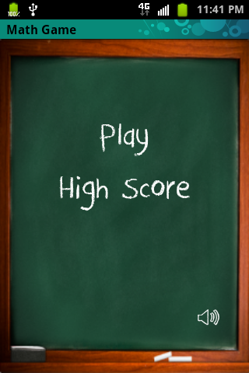 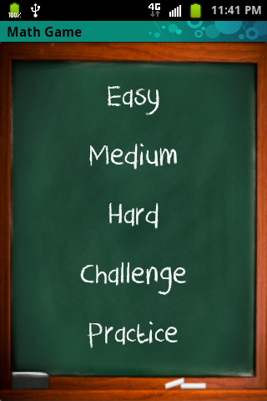 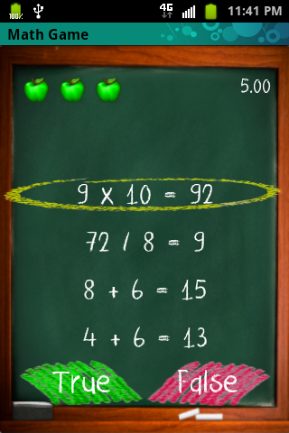

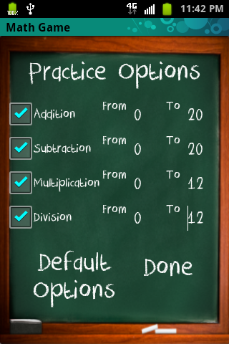 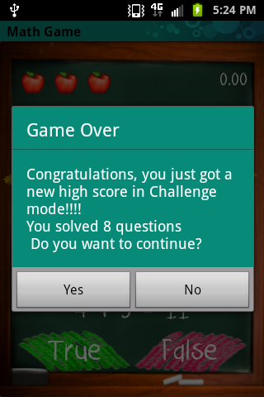 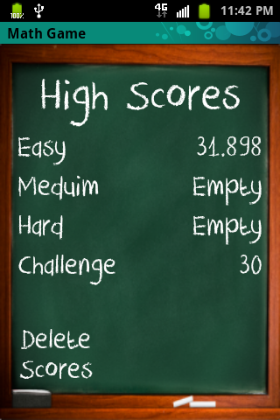

|  |  |  |  |  |
| --- | --- | --- | --- | --- |
| **Total Programming Project Hours** | | | | |
|  |  |  |  |  |
|  |  |  |  |  |
| **Week** | **Hours** | **Members** |  | **Total Hours: 132** |
| Week 9 | 7 | JV, JC, FA |  |  |
| Week 10 | 10 | JV, JC, FA |  |  |
| Week 11 | 9 | JV, JC, FA |  |  |
| Week 12 | 5 | JV, JC, FA |  |  |
|  |  |  |  |  |
|  |  |  |  |  |
|  |  |  |  |  |
| Week 7 | 9 | JV |  |  |
| Week 9 | 6 | JV |  |  |
| Week 10 | 7 | JV |  |  |
| Week 11 | 11 | JV |  |  |
| Week 12 | 3 | JV |  |  |
|  |  |  |  |  |
|  |  |  |  |  |
|  |  |  |  |  |
| Week 9 | 10 | JC |  |  |
| Week 10 | 15 | JC |  |  |
| Week 11 | 12 | JC |  |  |
| Week 12 | 4 | JC |  |  |
|  |  |  |  |  |
|  |  |  |  |  |
|  |  |  |  |  |
| Week 9 | 12 | FA |  |  |
| Week 10 | 7 | FA |  |  |
| Week 12 | 5 | FA |  |  |
|  |  |  |  |  |